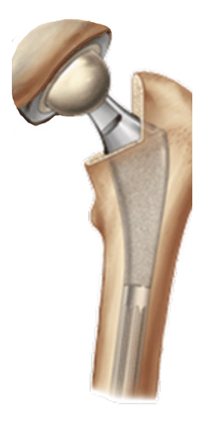  Total Hip Arthroplasty  Intra - Operative Data Form Version 10  Revised 12/2022 |  |  | [Place patient label here]  Name:  (Last, First, and Middle)  Identification #: Date of Birth: ____/ /
Operative Site: Left Right |  | Bilateral Procedure: No Yes (If yes, please complete two forms)
Anesthesia: (Mark all that apply) General Spinal Epidural Block Local
Tranexamic Acid: (Mark all that apply) None Topical IV Oral
Blood Transfusion: Yes No |  |  |  | Units Transfused: _________
Actual Procedure Type:
Primary Total Hip Arthroplasty (Conventional) Primary Total Hip Arthroplasty (Resurfacing)
Conversion of Previous Hip Surgery to Total Hip Arthroplasty Revision Total Hip Arthroplasty
If this is a revision, please indicate reason(s) below: (Mark all that apply)
Joint Infection Malalignment Metal Reaction/Metallosis
Aseptic Loosening Osteolysis Liner wear
Implant Failure Instability/Dislocation Peri-prosthetic Fracture (Femur)
Peri-prosthetic Fracture (Acetabulum) Pain

Device Fixation:  (Mark all that apply) | Acetabular Component Uncemented Cemented  Femoral Component Uncemented Cemented
Antibiotics added to cement:  (Mark all that apply) | - None - Cefazolin - Cefuroxime Clindamycin Erythromycin Vancomycin Ciprofloxacin Gentamycin Other*____________________ Colistan Tobramycin
Antibiotics added to cement by: | Manufacturer Surgeon
Cement – other use? | No Yes (Examples: liner cemented to acetabular shell; antibiotic beads; build up  of bony defect, other)
Was antibiotic powder  introduced into the joint space? | Yes No
What was used in the Irrigant?  (Mark all that apply) | Antibiotic solution CHG-containing solution Povidone-iodine  Normal Saline Other*___________________________
Surgical Approach:  (Choose 0ne) | Anterior Antero-Lateral Posterior  Transtrochanteric Other*__________________________________________________
Optional Techniques:  (Mark all that apply) | None Custom Implants Computer assisted Pre-fabricated Block  Extended Trochanteric Osteotomy – ETO  Robotic Surgery - Options: Cori Mako Navio Omnibotic  Orthotaxy Robodoc Rosa Other*__________________________________________
Intra-op Complications:  (Mark all that apply) | None Nerve Injury Vascular Incident  Ligament/Tendon Injury Fracture Other*___________________________  ________Fracture
*If other is indicated, specification required.
Cement and Implants – Please place stickers

Cement/Other
Acetabulum

Femur

