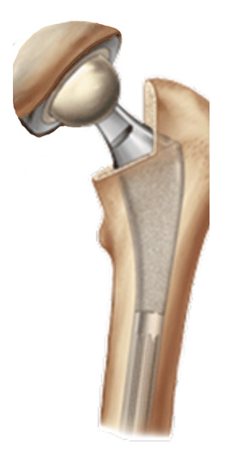  Total Hip Arthroplasty  Intra - Operative Data Form Version 8.3  Revised Sept 2019 |  |  | [Place patient label here]  Name:  (Last, First, and Middle)  Identification #: Date of Birth: ____/ /
Operative Site: Left Right |  | Bilateral Procedure: Yes No (If yes, please complete two forms)
Case is Scheduled As: Inpatient Outpatient
Anesthesia: (Mark all that apply) General Spinal Epidural Block Local
Tranexamic Acid: (Mark all that apply) None Topical IV Oral
Blood Transfusion: Yes No |  |  |  | Units Transfused: _________
Actual Procedure Type:
Primary Total Hip Arthroplasty (Conventional) Primary Total Hip Arthroplasty (Resurfacing)
Conversion of Previous Hip Surgery to Total Hip Arthroplasty Revision Total Hip Arthroplasty
If this is a revision, please indicate primary and secondary reason(s): (Circle all that apply)
Joint Infection Malalignment Metal Reaction/Metallosis
Aseptic Loosening Osteolysis Poly liner wear
Component fracture/failure Instability/Dislocation Peri-prosthetic Fracture (Femur)
Peri-prosthetic Fracture (Acetabulum) Pain (Rarely a Chief Reason)

Device Fixation:  (Mark all that apply) | Acetabular Component Uncemented Cemented  Femoral Component Uncemented Cemented
Antibiotics added to cement by  Surgeon (check all that apply) | - None - Cefazolin - Cefuroxime Clindamycin Erythromycin Vancomycin Ciprofloxacin Gentamycin Other Colistan Tobramycin
Cement used other than for  fixation to major component? | No Yes (Examples: poly liner cemented to acetabular shell; antibiotic beads; build up  of bony defect)
Was antibiotic powder  introduced into the joint? | Yes No
What was used in the Irrigant? | Antibiotic solution CHG-containing solution Povidone-iodine  Normal Saline Other
Surgical Approach:  (Choose One) | Anterior Antero-Lateral  Posterior Transtrochanteric
Optional Techniques:  (Mark all that apply) | Custom Implants Computer assisted Robotic Assisted  Extended Trochanteric Osteotomy – ETO None
Intra-op Complications:  (Mark all that apply) | None Nerve Injury Vascular Incident  Ligament/Tendon Injury Fracture Other______  ________Fracture

Cement and Implants – Please place stickers

Cement/Other
Acetabulum

Femur

